Dr. Richard Turner, Rector 269.993.4822

1045 East Wilson Street holytrinitysh@gmail.com

P.O. Box 261 www.holytrinitysh.com

**Holy Trinity**

**Anglican Church**



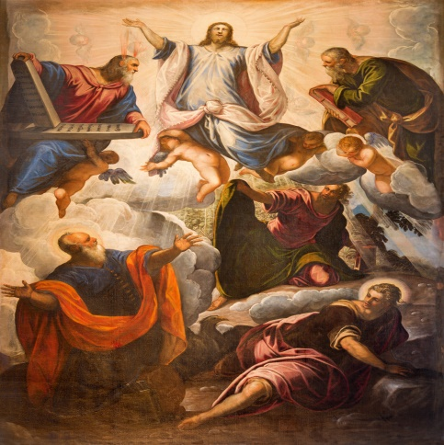

**The Transfiguration**

**August 6, 2017**

*Almighty and merciful God, it is only by your grace that your faithful people offer you true and laudable service: Grant that we may run without stumbling to obtain your heavenly promises; through Jesus Christ our Lord; who lives and reigns with you and the Holy Spirit, one God, now and forever.* *Amen.*

🕈

**Order of Service**

**Call to Worship** I Bless Your Name

The Old Rugged Cross

In the Secret

**Processional Hymn** Immortal, Invisible

Opening Prayer

First Lesson Exodus 34:29-35 Psalm 99

Second Lesson 2 Peter 1:13-21

**Sequence Hymn** Spirit of the Living God

Gospel Luke 9:28-36

The Homily Fr. Rick Turner

The Nicene Creed

Prayers of the People

Confession and Absolution

The Peace

**Offertory Hymn** How Great is Our God

The Great Thanksgiving

Sanctus

The Lord’s Prayer

The Breaking of the Bread

**Communion Hymns** Holy Spirit

Jesus Messiah

Prayer of Thanksgiving

**Recessional Hymn** I Want to Walk as a Child of the Light

**Servant Ministry**

**Today**

Greeter: Dennis DeVinney

Reader: Carol Bailey

Intercessor: Kathy Sicard

Chalice: Don Kuick

Host: Susan & Gary Katt

Altar Guild: Carol Bailey & Dawn Darling

Tellers: Todd Brugh and Helga Costello

🕈

**Next Week**

Greeter: John Michkovits

Reader: Dennis DeVinney

Intercessor: J.D. Diebold

Chalice: Marie Hudson

Host: Lynne Maxwell

Altar Guild: Carol Bailey & Kim Maxwell

Tellers: Ron Darling & Margaret Todd

Each one should use whatever gift he has received to serve others, faithfully administering God’s grace in its various forms. ~ **1 Peter 4:10**

**MC900361874[1]**

**Preparation Devotional ~ August 13th**

1 Kings 19:9-18 Psalm 85:8-13

Romans 10:5-15 Matthew 14:22-33

**The Collect**

Almighty God, give us the increase of faith, hope, and love; and, so that we may obtain what you have promised, make us love what you command; through Jesus Christ our Lord who lives and reigns with you and the Holy Spirit, one God, for ever and ever. Amen.

MCj04350990000[1]All baptized Christians are welcome to come to the

Lord’s Table. If you have a need or you wish to stand in for someone with a need, please come to the side altar where someone will pray with you.

**HTAC This Week**

**M 8/7**

*Group* Prayer

Hope Reformed Church........................................12:00 pm

**W 8/9**

*Men’s Group*

Walt Sicard Car Co…............................................6:00 am

*Picnic in the Park*

Kid’s Corner...…….............................................6:00 pm

*Praise Band Rehearsal*

HTAC……....…….............................................8:00 pm

**⬩ Family the Week ⬩**

Gary & Deb Myers

**July 30, 2017**

Attendance: 32

**Feedback/Suggestion Box**

As the Vestry, we're always looking to improve our service to the parish. In that spirit we are looking to you for feedback in the form of comments, observations or suggestions. A feedback box is located on the counter along with feedback cards for your convenience. We are grateful to you for your consideration in this area.

 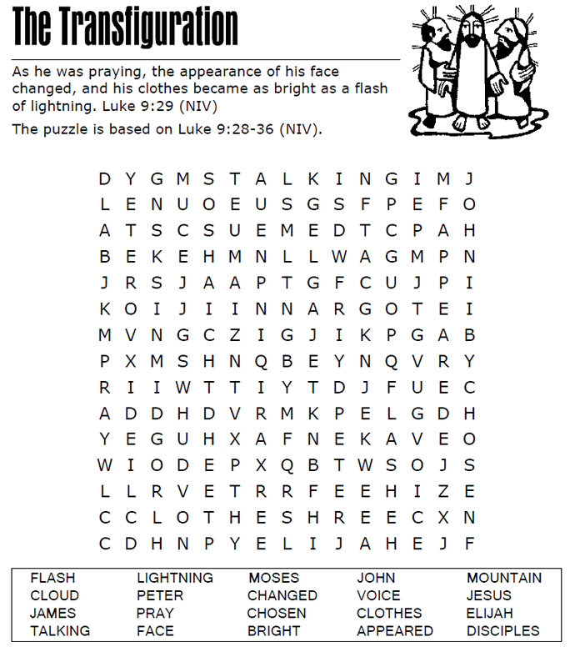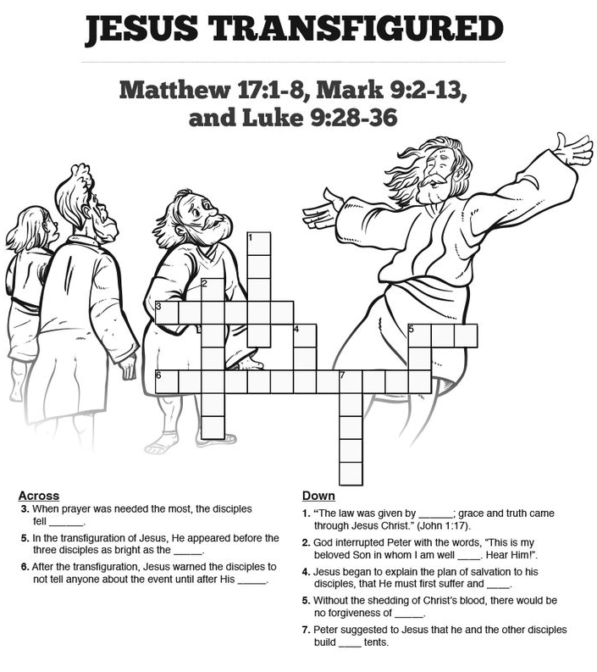

Notes: