**Holy Trinity Anglican Church**

**Making Disciples by Being Disciples**



Dr. Richard Turner, Rector 269.993.4822

1045 East Wilson Street holytrinitysh@gmail.com

P.O. Box 261 www.holytrinitysh.com



**The Second Sunday in Lent**

**February 25, 2018**

*Almighty God, you know that we have no power in ourselves to help ourselves: Keep us both outwardly in our bodies and inwardly in our souls, that we may be defended from all adversities which may happen to the body, and from all evil thoughts which may assault and hurt the soul; through Jesus Christ our Lord; who lives and reigns with you and the Holy Spirit, one God, for ever and ever. Amen.*

🕈

**Order of Service**

**Call to Worship** The Old Rugged Cross

10,000 Reasons

Come, Holy Spirit

**Processional Hymn** The God of Abraham Praise

Opening Prayer

First Lesson Genesis 17:1-7, 15-16

Psalm 22:22-30

Second Lesson Romans 4:13-25

**Sequence Hymn** Revelation Chorus

Gospel Mark 8:31-38

The Sermon Fr. Rick Turner

The Nicene Creed

Prayers of the People

Confession and Absolution

The Peace

**Offertory Hymn** Great is Thy Faithfulness

The Great Thanksgiving

Sanctus

The Lord’s Prayer

The Breaking of the Bread

**Communion Hymns** Lead Me to the Cross

Born Again

Prayer of Thanksgiving

**Recessional Hymn** Abide with Me

**MC900361874[1]**

**Preparation Devotional ~ March 4th**

Exodus 20:1-17 Psalm 19

1 Corinthians 1:18-25 John 2:13-22

**The Collect**

Heavenly Father, you made us for yourself, and our hearts are restless until they rest in you: Look upon the heartfelt desires of your humble servants, and stretch forth the strong hand of your Majesty to be our defense against our enemies; through Jesus Christ our Lord; who lives and reigns with you and the Holy Spirit, world without end. Amen.

MCj04350990000[1]All baptized Christians are welcome to come to the

Lord’s Table. If you have a need or you wish to stand in for someone with a need, please come to the side altar where someone will pray with you.

**HTAC This Week**

**M 2/26**

*Group* Prayer

Hope Reformed Church...........................................12:00 pm

**T 2/27**

*Women’s Bible Study*

TBA………. …………............................................9:30 am

*Women’s Book Group*

Dana Turner’s…………............................................6:30pm

**W 2/28**

*Men’s Group*

Walt Sicard Car Co…................................................6:00 am

*Pizza Night*

Maria’s………….…................................................6:00 pm

*Praise Band Rehearsal*

HTAC……………..... ............................................8:00 pm

**February 18, 2018**

Attendance: 28

Offering: $1519

**⬩ Family the Week ⬩**

Allison and Nick Simon

**Servant Ministry**

**Today**

Greeter: Walt Sicard

Reader: Dana Turner

Intercessor: J.D. Diebold

Chalice: Don Kuick

Host: Susan & Gary Katt

Tellers: Todd Brugh & Dana Turner

Altar Guild: Carol Bailey & Dawn Darling

🕈

**Next Week**

Greeter: Norm Bailey

Reader: Laura Jager

Intercessor: Lynne Maxwell

Chalice: Walt Sicard

Host: Don & Celia Kuick

Tellers: Helga Costello & Ron Darling

Altar Guild: Carol Bailey & Dawn Darling

Each one should use whatever gift he has received to serve others, faithfully administering God’s grace in its various forms. ~ **1 Peter 4:10**

**Vision Statement**

The votes are in…

Our new vision statement is official. *Making Disciples by Being Disciples*. Spread the word! And the Word!

**Bishop’s Visit**

The Bishop is visiting our parish in April and will be available for confirmations. If you would like to be included with others who have said yes, please see Father Rick as soon as possible.

**Lenten Website**

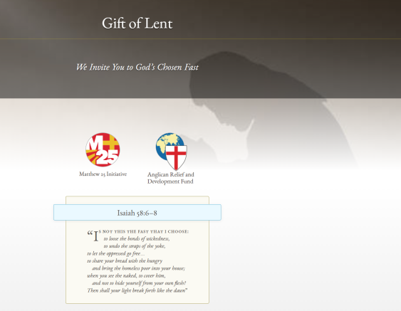 At the Gift of Lent website you will find a wealth of resources for your Lenten season, including a link to Morning and Evening prayer.

<https://giftoflent.org/>

**Servant’s Calendar**

It’s just about time for a new calendar. Please check the current sign-up at the back counter to be certain your name is on the ministry list(s) of your preference. Also, please be reminded, if you have not served in the past, you are more than welcome to join the fun!



Notes:

